Your Assurance of Pure Silk | BANGALORE CHAPTER  SILK MARK ORGANISATION OF INDIA  [Sponsored by Central Silk Board, Ministry of Textiles, Govt., of India]  # 14, Vatal Nagraj Road, Oklipuram, Bangalore-21.  Regd., No. 1054/2003-04 Ph: 080-2342 1144

No: SMOI/BLR/EXPO/6A/2015-16/Bangalore Date: 05-10-15
To

Dear Sir,
Sub: Silk Mark Vanya Silk Expo 2015 Bangalore inviting lowest quote for providing Infrastructure
Facilities and services - regarding.
*****************
The Silk Mark Organisation of India,(SMOI) promoted by Central Silk Board, Ministry of Textiles, Government of India is planned to organize National level Exhibition cum Sale of Silk Mark Vanya Silk Expo 2015 Bangalore from 15th to 20th Dec 2015 ( 6 Days) in the garden city, Bangalore at Safina Plaza, Infantry Road, Bangalore-560 001 The Expo is organized for the promotion of Indian Silks and Silk products to popularize Silk Mark Label, a purity Symbol of silk through the Authorised Users of Silk Mark..
In this connection, the Exhibition organizing committee is looking for a well experienced service provider for providing Infrastructure facilities and basic service of the expo.. The details of requirements of infrastructure and the desired service for the forth coming Silk Mark Expo 2015 Bangalore are specified below.

# | Particulars | Specifications
1 | Fabrication of Stalls 45 Nos Each Stall fabricated with white Octonorm Board. 3 Tables with white cloth, 2 Nos Chairs, 4 spot Lights (Yellow LED), one power plug, Fascia with name and stall Nos  (Projected from the back panel with three Shelves 8’ H x 10’ W - as per design enclosed) | Size - 3m x 2 m
2 | Fabrication with octonorm partition for theme pavilion )  Tables round  Display Tables  Spot Lights  Chairs | 2 Nos  10 Nos  20 Nos  10 Nos
3 | VIP Room Box Type Sofa Seaters (4 +2 Nos)  VIP Chairs  Tee Poy | 1 set  8 Nos  2 Nos
4 | Fabrication with octonorm partition for Expo Office )  Display Tables  Spot Lights  Chairs  Power plugs | 10 Nos  10 Nos  6 Nos  4 Nos
5 | Floor carpeting - new carpet only  (Mono type Synthetic carpet- colour to be matched with fascia. Passage & Theme pavilion, VIP room in Red colour and stalls in Grey colour) | App 7,500 Sq.ft
6 | Exhibition entrance (flux digital printing & fixing) | 2’x8’- 3No + 3’x32’ -1no
7 | Information Counter with octonorn partition  6 tables + 4 chairs, 1 fan,6 spot lights power plug | 1 No
8 | For inaugural day  Flower Decoration for Arches, Venue entrances  Lighting Lamp -5 ft decorated with flowers  Flower Bouquets for VIP and Ribbon, Scissor, Tray, Candle | 1No  6 Nos
9 | Steel Almirahs | 2 Nos
10 | Mirrors with stand ( 1.5 ft x 5ft) | 6 Nos

Conti…………2

-2-

11 | Drinking Water supply for 6 days | 15 cans per day
12 | Security for 6 days @ 4 Nos per day | 24 Mandays
13 | Pedestal Fans | 10 Nos
14 | Participation List display in flux printing with frame  Stall Layout display in flux printing with frame | 1 No  1 No
15 | 1. Flux printing for 10 pillars box type as per art work  2. Flux printing near entrance – 1 No as per art work | 38”x 20” x 11’  10’x 8’
16 | Extra furniture for stalls on rent basis -( tariff to be furnished) | Mandatory
17 | Any other requirement on actual basis

Mandatory permissions required to be obtained from the concerned Government offices like Corporation, Police, Health and Fire in coordination with SMOI officials.

In view of above requirement, you are requested to kindly furnish your proposal in two parts

- Your Company profile with details of company’s core team, experience in assignments undertaken so far, strength and capabilities, No. of Exhibitions conducted at Bangalore and other places

- Your best Quote / Rate/ Rent on unit and Sq.ft and No. basis with respect to above heads of Items and activities in separate sealed envelopes to be sent to the undersigned on or before 23RD November 2015 along with an EMD AMOUNT @ 2 % of the quoted amount drawn in Nationalised Banks /reputed banks .

The responding agencies would be first scrutinized on the basis of their part (a) technical information and only the short listed firms would be invited on specified date for tender opening procedure and comparison of the part( b) financial details.

The final selection of the firm / agency would be on the basis of lowest Financial Quote, Merit and field experience.

The programme is self sustainable with a limited budget and for promotion of Silk Mark among Traders and Consumers. Keeping in view, your possible lowest quotation is invited.

The terms and conditions is enclosed herewith for reference,

Yours faithfully,

Encl:1..Terms and conditions (P.M.Pandi)
2. Particulars of details – Part (a)&Part (b). Deputy Director (Insp.)
3. Floor plan Sr.Executive

Suggested formats for Part A (Technical)

Sl.No | Particulars | Details
1 | Background information of the company /firm
2 | Details of achievements & experience in organizing exhibitions / expos etc
3 | Introduction of core team and profile of members
4 | Total No of exhibitions conducted at Bangalore
5 | Major Strengths and capabilities
6 | Profiles of major clients ( details to be enclosed)
7 | Any other relevant information

Suggested formats for Part B (Financial)

# | Particulars | Specifications | Quoted price (per Unit/ Sq.ft / Nos, etc) | Total  Amount in Rs
1 | Fabrication of Stalls 45 Nos  Each Stall fabricated by Octonorm Board. 3 Tables with white cloth, 2 Nos Chairs, 4 spot Lights (Yellow LED), one power plug, Fascia with name and stall Nos  ( Projected from the central panel with three Shelves 5’ H x 8’ W - as per design enclosed ) | Size - 3m x 2 m
2 | Fabrication with octonorm partition for theme pavilion )  Tables round  Display Tables  Spot Lights  Chairs | 2 Nos  10 Nos  20 Nos  10 Nos
3 | VIP Room Box Type Sofa Seaters (4 +2 Nos)  VIP Chairs  Tee Poy | 1 set  8 Nos  2 Nos
4 | Fabrication with octonorm partition for Expo Office )  Display Tables  Spot Lights  Chairs  Power plugs | 10 Nos  10 Nos  6 Nos  4 Nos
5 | Floor carpeting - new carpet only  (Mono type Synthetic carpet- colour to be matched with fascia. Passage & Theme pavilion, VIP room in Red colour and stalls in Grey colour) | App 7,500 Sq.ft
6 | Exhibition entrance (flux digital printing & fixing) | 2’x8’- 3No + 3’x32’ -1no
7 | Information Counter with octonorn partition  6 tables + 4 chairs, 1 fan,6 spot lights power plug | 1 No
8 | For inaugural day  Flower Decoration for Arches, Venue entrances  Lighting Lamp -5 ft decorated with flowers  Flower Bouquets for VIP and Ribbon, Scissor, Tray, Candle | 1No  6 Nos
9 | Steel Almirahs | 2 Nos
10 | Mirrors with stand ( 1.5 ft x 5ft) | 6 Nos
11 | Drinking Water supply for 6 days | 15 cans per day
12 | Security for 6 days @ 4 Nos per day | 24 Mandays
13 | Pedestal Fans | 10 Nos
14 | Participation List display in flux printing with frame  Stall Layout display in flux printing with frame | 1 No  1 No
15 | 1. Flux printing for 10 pillars box type as per art work  2. Flux printing near entrance – 1 No as per art work | 38”x 20” x 11’  10’x 8’
16 | Extra furniture for stalls on rent basis -( tariff to be furnished) | Mandatory
17 | Any other requirement on actual basis

Total Amount = Rs.
Service Tax = Rs.

SILK MARK ORGANISATION OF INDIA.
BANGALORE CHAPTER

SILK MARK EXPO INFRASTRUCTURE WORK TERMS AND CONDITIONS:

- RATES AND APPLICABLE TAXES: The parties should clearly quote the rates on per unit/sq.ft basis and applicable rate of service and any other taxes

- FLUX PRINTING: The quality of the flux printing is to be used only Star Flux 4 pass

- ESCALATION CHARGES: No escalation charges will be entertained during the currency of the contract, once the service provider is accepted and contract is awarded.

- VALIDITY: The rates quoted should be valid for a period of 60 days from the date of opening the service provider.

- E.M.D: The service provider should be accompanied with 2 % EMD of the total amount quoted drawn in favour of “Silk Mark Organisation of India” by a demand draft/pay order payable at Bangalore from a Nationalized / Reputed banks. The service provider received without EMD will be summarily rejected.

- LAST DATE FOR SUBMISSION OF SERVICE PROVIDER ( PART A & B) : The last date for submission of the sealed competitive quotation is 26-11-2015 up to 3.00 P.M. The envelope containing the competitive quotation should be sealed and submitted to The Deputy Director(Insp.)/Sr Executive, Silk Mark Organisation of India, Bangalore Chapter, Central Silk Board, “Resham Bhavan’ #14, Vatal Nagaraj Road, Okalipuram, Bangalore-560 021 duly super scribing on the envelope as “SERVICE PROVIDER FOR SILK MARK VANYA SILK EXPO 2015 -INFRASTRUCTURE”.

- OPENING THE SERVICE PROVIDERS: The responding agencies would be first scrutinized on the basis of their PART A INFORMATIONS on 26-11-2015 and only the short listed firms would be invited on the same day i.e 26-11-15 at 4.00 pm for tender opening process and comparison of the PART B DETAILS. The final selection of the firm/ agency would be on the basis of lowest financial quote.

- LATE QUOTATIONS: The service providers received after the due date and time prescribed shall be summarily rejected.

- REFUND OF E.M.D: The EMD amount of the unsuccessful bidders shall be returned, by a cheque, within 60 days from the date of opening of the service provider. The EMD of the successful service providerer shall be adjusted in the final payment.

- RIGHT TO ACCEPT OR REJECT: The Sr Executive, Silk Mark Organsiation of India, Central Silk Board, Bangalore, reserves the right to accept or reject any [or] all the service providers either in part or in full without assigning any reason’s/ thereof.

- PAYMENT: The bill of cost for rendering desired service supply shall be made within 30 days after the satisfactory completion of the event. No advance payment shall be made.

- ADDITIONAL INORMATION, IF ANY: For any/all information, the successful service provider may contact The Deputy Director(Insp.)/Sr Executive, Silk Mark Organisation of India, Central Silk Board, ‘Resham Bhavan, #14, Vatal Nagaraj Road, Okalipuram, Bangalore – 560 021.
(Phone:23421144 / 23120274). web: silkmarkindia.com

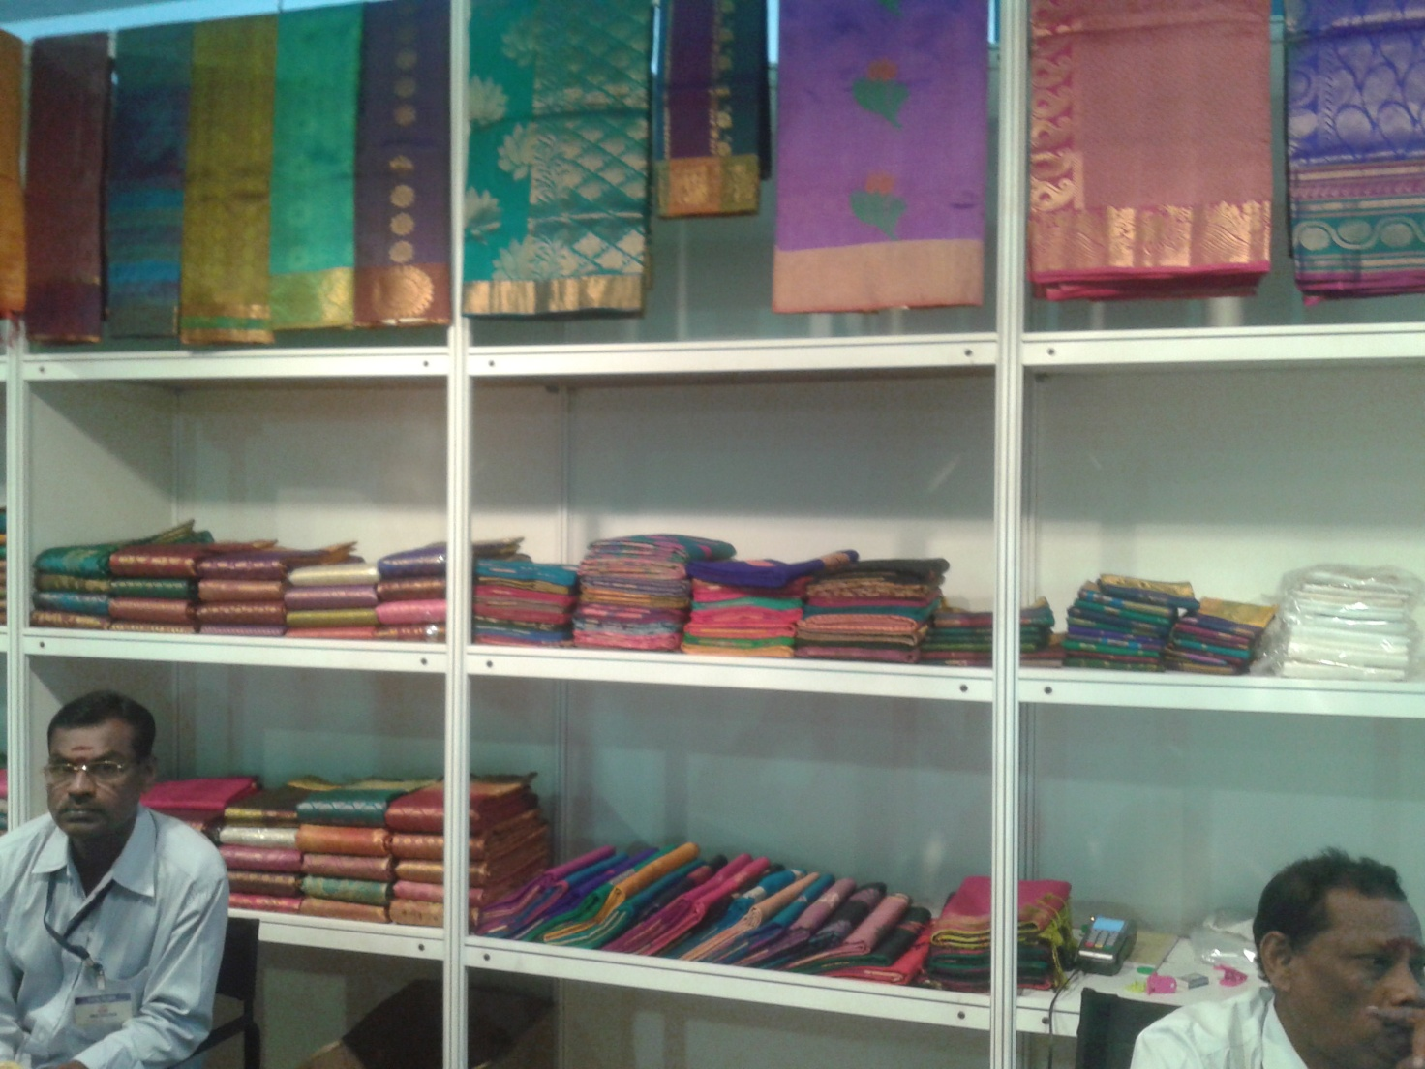

Rack Design

