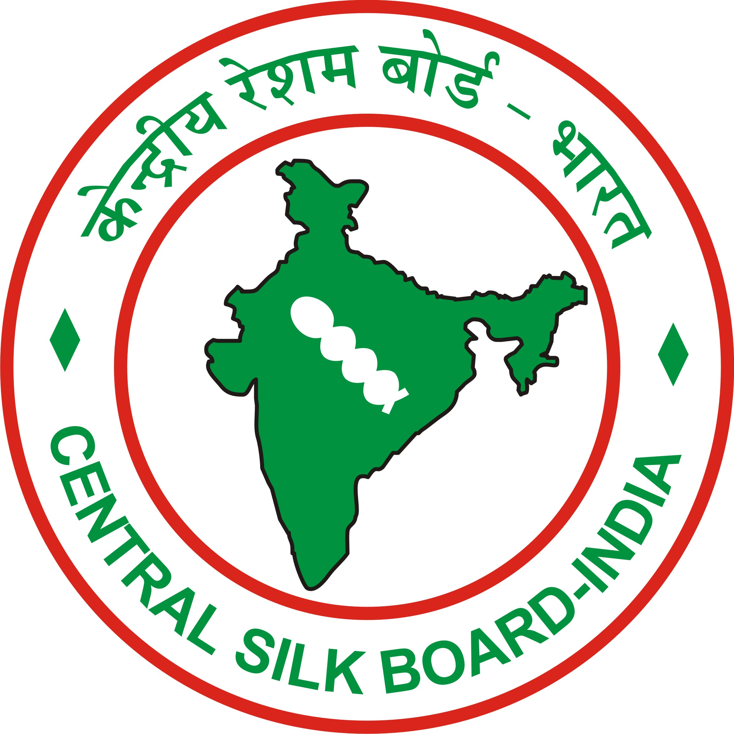 | CENTRAL SILK BOARD  SILK MARK ORGANISATION OF INDIA  Ministry of Textiles, Govt. of India  15, Gariahat Road, Kolkata - 31  Kolkata - 700031  Ph. 033 – 2473 6856 , 2473 0912,  visit : www.silkmarkindia.com E-mail: kolkata@silkmarkindia.com  E-mail: rokol.csb@nic.in | 
No. CSB / RO/KOL/27/2017-18/SMOI/ EXPO/ Dated: 15.03.2022
To,
M/S.
Respected Silk Mark Members,

Sub: Invitation to Participate in National Level Expo, Silk Mark Expo 2022 at Patna
on revised schedule dates (5 Days)- Reg.

The Silk Mark Organisation of India, Central Silk Board is organizing National Level Expo –Silk Mark Expo 2022 at Patna, now rescheduled from 27th April, 2022 to 1st May, 2022 (5 Days) for an Exhibition cum sale of 100% Pure Silk Products affixed with Silk Mark Labels. The active Authorized Users of SMOI are invited to participate and utilize the opportunity to display & sell their 100 % Silk Products with Silk Mark Tags during this Expo.

1 Duration |  |  | w.e.f 27th April, 2022 to 1st May, 2022 ( 5 Days )
2 Venue |  |  | Hotel Patuliputra Exotica, Exhibition Road, Patna – 800001
3 Timings |  |  | From 11.00 AM To 8.00 PM
4. Stall rent details :-
Stall Size/Type | No. of Stalls |  |  | Stall rent with GST (Rs.)
A. 3X2Mts. | 26 |  |  | 33,040.00
A1. 3X2Mts | 13 |  |  | 37,760.00
B. 4X2Mts. | 08 |  |  | 41,300.00
First cum first basis for desired stall number can be booked on payment of FULL rental charges.
Draw of lottery will be the basis for other allottees who need to pay 50% in advance for the specified stall type
5. Mode of Payment |  | Demand Draft in favour of Silk Mark Organization of India, payable at Kolkata or RTGS/NEFT/CBS through Central Bank Of India, A/C No. 3007723602, IFSC Code CBINO280090. Stall will be confirmed only after receipt of full Payment on or before 25.04.2022 failing which stall will be re-allotted to the AUs from the waiting list. Stall will be allotted on First cum first serve basis depending upon the availability of stall subject to acceptance of application by the chapter.
6 Booking last Date |  | 22.04.2022 with 50% advance amount
7 Cancellation /Refund  procedure
  On or before 23.04.2022 ( 75% Refund )
  On or before 24.04.2022 ( 50% Refund)
  On or after 25.04.2022 (No Refund)
8. Pre-Qualification Criteria |  | Only 100% Pure Silk Products would be allowed to display and sell in the Expo. All products shall invariably be tagged with Silk Mark Labels and also Price Tags. The AUs of Silk Mark are allowed to participate in the National Level Silk Mark Expo, at Patna.
10. Credit Card Facility |  | Debit / Credit facility will be arranged by SMOI through a service provider.
11. Facilities  to be provided |  | Table, Chairs, Fascia, Wooden / Steel rack for storage of Silk Materials, Halogen lights.
For further details you may please contact Sri N Giridhar Srinivas - Mobile No. 9886808697 &
Shri Sanjoy Roychowdhury, Mobile No.9064076935, SMOI, Kolkata.

Yours Faithfully
All required documents are enclosed.
Sd/-
G.K.Samanta
Nodal Officer, SMOI, Kolkata
Mobile -8902016458

TERMS AND CONDITIONS

Stalls for participation in the Silk Mark Expo 2022, Patna are available only for the Registered Members cum Active Authorised User of Silk Mark on the following terms and conditions:

- All the participants have to produce the current Silk Mark- AU certificate mentioning the validity period, and also copy of Handloom Registration Certificate.
- Only 100% Silk & Handloom Products are allowed for display & sale in the Expo
- All the products display for sale shall invariably be tagged with Silk Mark label along with Price Tag.
- Expo Participant should have prescribed Bill Book in triplicate (White, Pink and yellow as one set) to maintain uniformity in Silk Mark Expos.
- Exhibitors are NOT allowed to bring Non-Silk / Mixed Silk Products into the Exhibition hall and these are banned during the Expo. In case any product found to be of Non-Silk, the same will seized by the organizing authority.
- Confirmation of stall allotment will be done only after the realization of RTGS/ NEFT/CBS for the full amount towards the stall rent.
- The stall will be allotted & confirmed on first come first serve basis depending upon the availability of stalls.
- No alteration to the size of the stall by the participant will be allowed. Modifications to the outer structure of the stalls are allowed only after it is ensured that the changes will not block or obstruct other exhibitors’ stall.
- Any damage or loss caused by exhibitor to any part of exhibition centre or to the goods belonging to other exhibitors will be charged for by the organizers from the exhibitors concerned.
- Tables, parts of the stall portion should not over hang the allotted area. No luggage, parcels should be kept near gangways, fire extinguishers points, emergency exits, Etc.
- Extra lights, fan, table etc., will be provided on request on Extra Charges. The extra amount has to be paid by the participant to the service provider directly.
13 Hoardings, Banners, Buntings, Wall Hangings will not be allowed to be displayed in the exhibition premises or on the roads in the vicinity unless their designs, specification, size, locations have been approved by the organizer. Playing Television sets with high volume is not at all permitted inside the stall as it disrupts the other participants.
14. A self-imposed discipline should be maintained on reasonable pricing and a maximum of 20% discount may be allowed & should not indulge in unfair bargaining, pricing.
- Strict discipline should be maintained during the Expo period and any violation of Silk mark and Handlooms Mark rules will be viewed seriously. The participants violating rules and regulations will be banned without assigning any reasons for future expos.
- The participants should allow the organizer for inspection of materials on display & sale in the expo as and when required for purity and fair pricing.
- Consumer satisfaction is of paramount importance for the success of the Expo and therefore all the participants should address consumer complaints, if any, immediately without altercation and/or arguments to the fullest satisfaction of consumer.
- The sales persons should be neatly dressed (Dress Code is White Shirt), speak in soft, mild voice with the consumers and should give utmost respect to them and also do business politely.
- The products displayed in the stall for sale should of good quality and no inferior quality products like old stock, torn, discolored should be displayed and sold in the expo.
- Only Authenticated Bills mentioning name of the shop should only be issued.
Rate / Price of the silk product should be properly mentioned in Sales
Receipt or Bills issued to consumers.
- No eatables, Food packets are allowed inside the Expo hall & stall.
- All the participants and salespersons should be present at the time of opening the main door leading to Expo hall. The expo hall will be opened (½) half an hour before scheduled time for proper cleaning. All the waste materials lying inside the stall should be handed over to cleaning personnel.

- Exhibited Material will not be allowed to taken out of exhibition premises without valid Gate pass provided by the organizer.
- Full and final payment towards the stall rent and any other dues should be paid by RTGS/NEFT/CBS before the concluding day of exhibition.
- Material will be seized if the participant is failed to pay stall rent at the end of event.
- No refund of payment will be made for cancellation of the stall space booked by the exhibitor after the commencement of the Expo.
- Subletting of allotted stalls is not permitted.
- All the exhibitors will abide by the rules and regulations laid down by SMOI.
- The decision of the organizers will be final and binding on all matters related to SMOI.
- The organizers shall be at liberty to change the dates, timing or venue of the exhibition owing to unavoidable circumstances or to cancel the exhibition for such reasons under advice to exhibitors.
- Cheque bounce is a serious offence under the law and all the participants should take proper precautionary measure before issuing a post dated cheque.
- Distribution of Hand bills, Pamphlets, Brochure at the entrance of the main expo hall or in front of the other’s stall is totally prohibited.
- Sufficient number of mirrors is being arranged inside the hall for the convenience of the consumers and these mirrors should neither be moved from its original place nor covered with saree samples.
- All efforts are being taken care including media publicity to make the Expo a grand success. However the sale of Silk products and business turn over is entirely the responsibility of the participants. Under any circumstances demand for discounting of the stall Rent is not entertained by the organizer.
- The AU’s are advised to provide their GSTN to organizers.
- SMOI won’t be providing Carry Bags. Exhibitor will bring their own Carry Bags.
We have read carefully all the rules and regulations of Silk Mark Expo 2022, Patna and hereby explicitly agree to comply with all rules and regulations contained there in.

We further agree to comply with such other rules as may be modified by exhibition authority from time
to time.

Company Name……………………..

Signature……………………………

Designation………………………..

(With rubber stamp)

EXHIBITOR’S PROFILE

1. Name and Address
of the Company :

2.: Contact Person :
3.: Telephone NO. :
4. Mobile No :
5.: E-mail ID :
6.: Branches if any :
7. Silk Mark A.U. Regn. No & Validity Date :
8. GSTN No.
9. Handloom Mark Registration No & Validity Date :
9. Company Status :
10. Products Profile :
11. Specialty Products : Manufacturer / Wholesaler / Trader
12. Price Range of Products :
13. Awards/Recognition Received :

Place:

Date: A.U’s signature with Seal
Name of the signatory

To,

The Joint secretary (Tech.)
Silk Mark Organization of India,
Central Silk Board,
Ministry of Textiles, Govt. of India
#15, Gariahat Road (South), 1st Floor,
KOLKATA– 700031.

Dear Sir,

We have read and understood carefully all the rules & regulations of Expo and hereby explicitly agree to comply with and hereby request you to confirm our stalls at Silk Mark Expo- 2022, Patna 27.04.2022 to 01.05.2022 as per the details mentioned below.

1. Exhibitors Name ……………………………………….
Address ……………………………………….
………………………………………

- Telephone No . ……………………………………….

- Mobile No. ……….…………..……………………

- E-mail ID …………………………………………

5. Name to appear on Fascia …………………………………………

6. Products to be exhibited …………………………………….….

7. No of Stalls applied for ……….… Preferred Stall Number (s) …..……….

8. Total amount for stalls (Rs.) ………………………..

- Advance amount (Rs.) ……………………..

- . RTGS / Cheque No …………………. Dated ………………..

Name of Bank………………………….Branch…………………………..
Company Name……………………..

Signature……………………………

Designation………………………..
(With rubber stamp)

